**DAILY ONLINE ACTIVITIES SUMMARY**

|  |  |  |  |  |  |  |  |
| --- | --- | --- | --- | --- | --- | --- | --- |
| **Date:** | 17/06/2020 | | | | **Name:** | AMBIKA V | |
| **Sem & Sec** | 4th Sem Section'A' | | | | **USN:** | 4AL18CS005 | |
| **Online Test Summary** | | | | | | | |
| **Subject** | | _ | | | | | |
| **Max. Marks** | | _ | | **Score** | | _ | |
| **Certification Course Summary** | | | | | | | |
| **Course** | Introduction to R | | | | | | |
| **Certificate Provider** | | | greatlearning academy | **Duration** | | | 3 hrs |
| **Coding Challenges** | | | | | | | |
| **Problem statement 1 :** Write a C Program to Count numbers that don’t contain 3  **Problem statement 2:** Write a Python program to check whether a given a binary tree is a valid binary search tree (BST) or not? | | | | | | | |
| **Status:** completed | | | | | | | |
| **Uploaded the report in Github** | | | | yes | | | |
| **If yes Repository name** | | | | https://github.com/ambika0202 | | | |
| **Uploaded the report in slack** | | | | yes | | | |

**ONLINE TEST DETAILS: N/A**

**CERTIFICATION COURSE DETAILS:**

**Name of the course**: Introduction to R.

**Certificate Provider**: Great Learning Academy

Today I have started a new course I.e., Introduction to R and started to learn about plot combination and exports plots.

**Snapshot:**

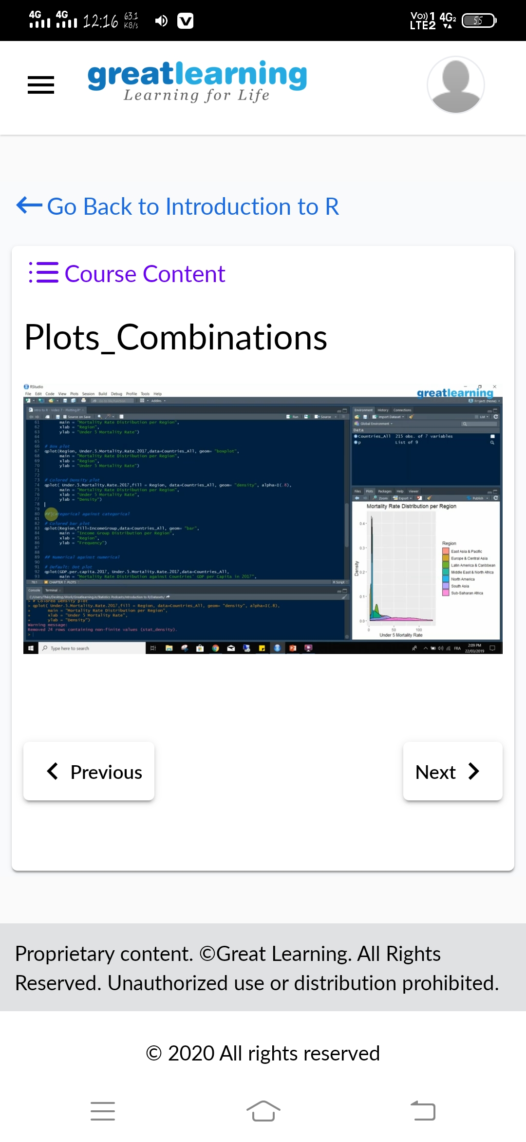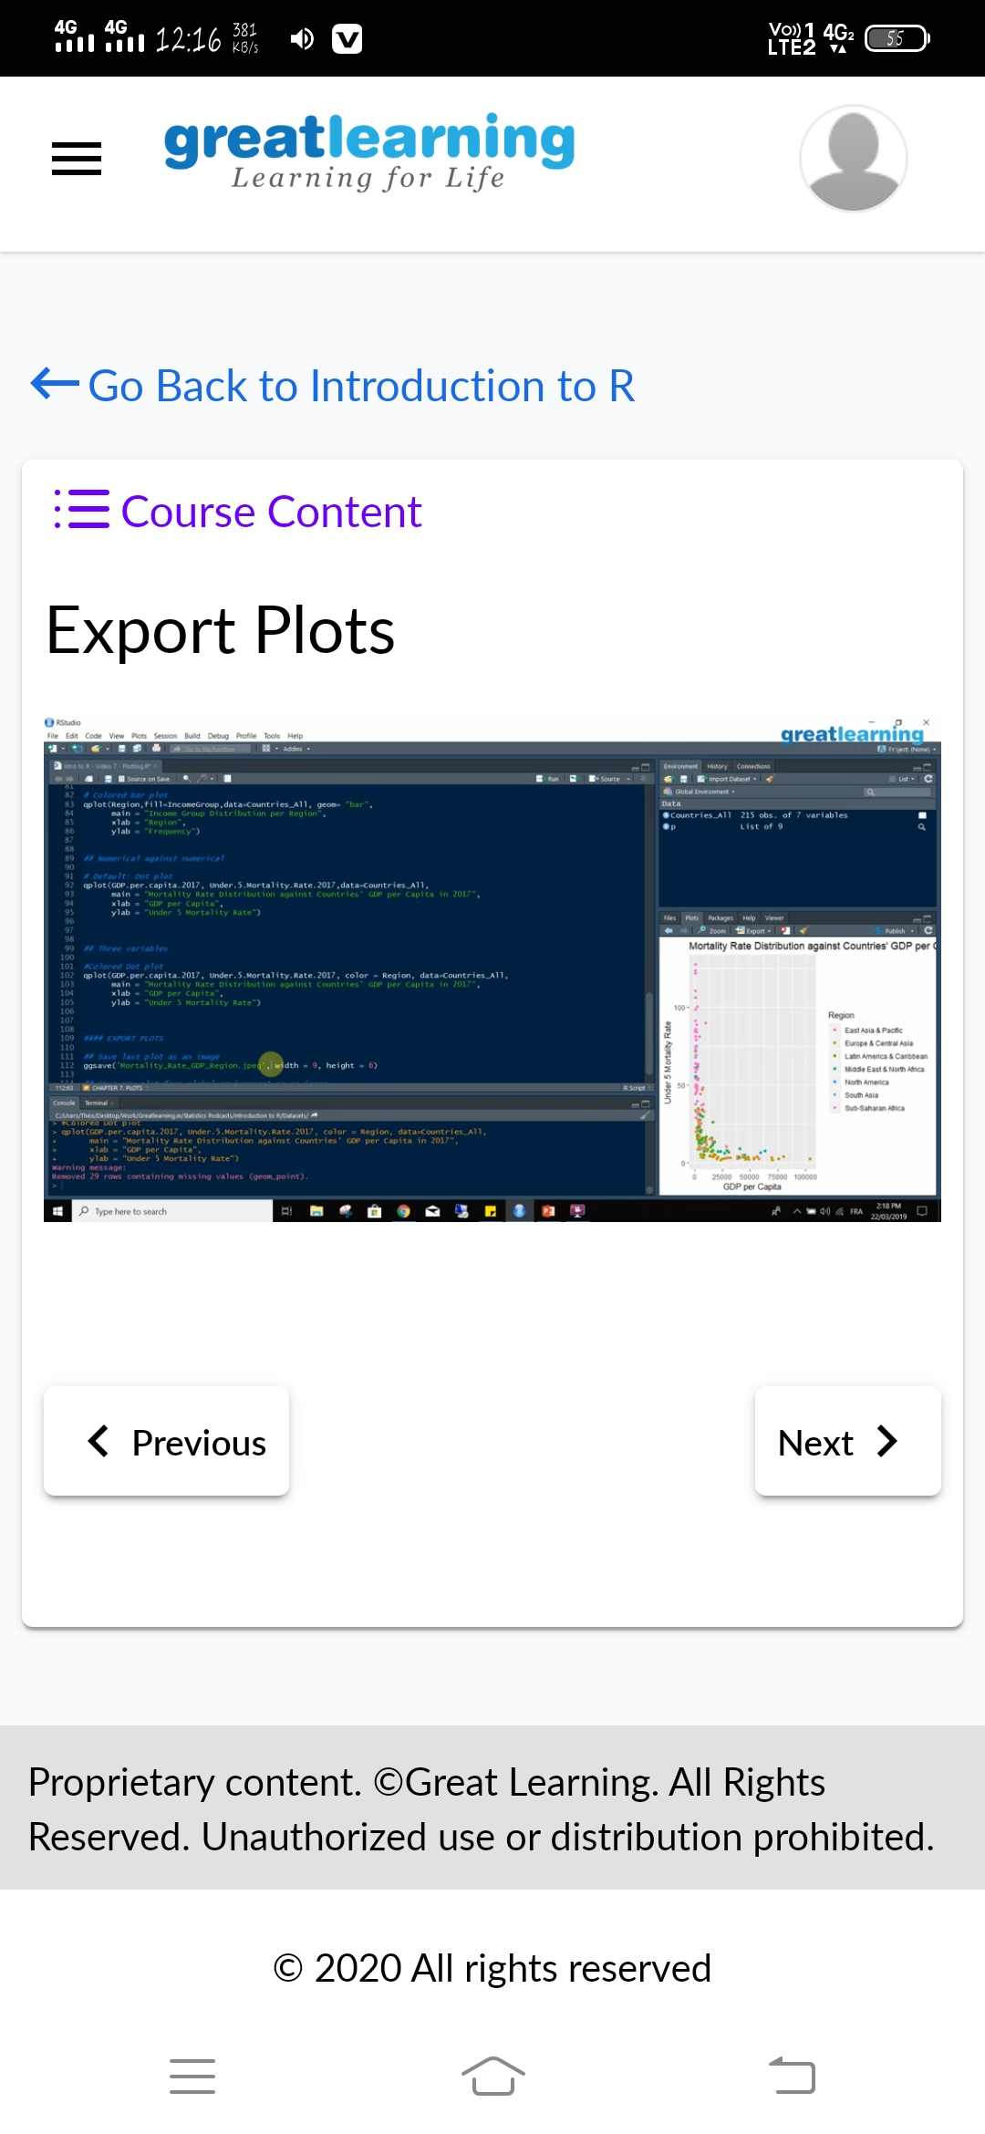

**CODING CHALLENGES DETAILS**: Every day we are given with new question of coding related to the language of java and c.

**Problem statement 1:**Write a C Program to Count numbers that don’t contain 3

**Solution is uploaded in Github**

**Snapshot:**

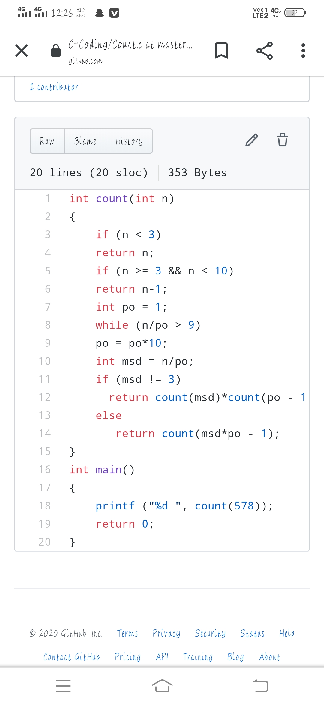

**Problem statement 2:** Write a Python program to check whether a given a binary tree is a valid binary search tree (BST) or not?

